**Development of Self assessment tool for domestic workers on decent working conditions using community life competence process**

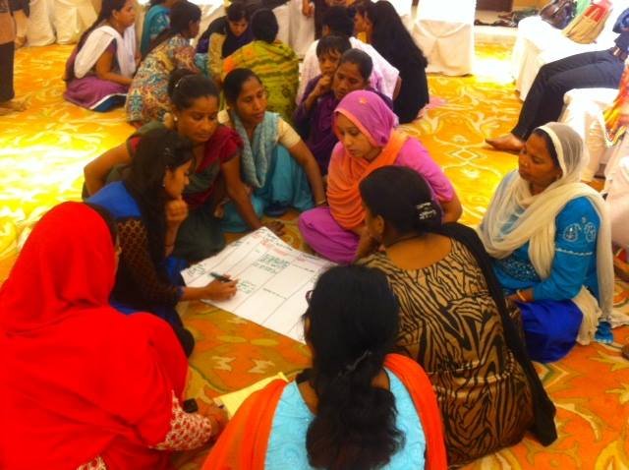

**Organized by**

**ILO, New Delhi**

**Facilitated by**

**Institute of Social Studies Trust –Bobby Zachariah, Rajib Nandi, Rituu B Nanda, Tanisha Jugran and Shiny Saha**

**June 2015**

Table of Contents

Dream Building 5

Introduction 5

The pre-test workshop 6

1: Articulating and understanding- who are we? What are our strengths? 8

What makes us human? 8

Exercise to bring out strengths 8

Hopes and Concerns 10

2: Dream building and designing a self assessment framework 14

Individual Dreams 14

Synthesized Dream 16

SALT Visit 18

Reflections session on previous day’s SALT visit 19

3: Developing indicators 20

Self assessment: Monitoring and Evaluation 25

4: Extracting practices of self-assessment from the dreams 26

Defining level 5 26

Final Reflections 29

Developing the self assessment framework and Action Plan 31

Background of the workshop 31

Revisiting the practices of the domestic workers 31

Importance of assessment 33

Defining the levels 34

Which level are we? 35

Observations by the stakeholders on the self assessment process (NGO, Trade Union, ILO, Families) 40

5: Where do we want to go in three months? Developing action plan on two key practices 41

What did we learn today? 42

SALT visit to Tigri area 43

Annexure 1: List of participants 44

Annexure 2: Agenda 45

Annexure 3: Salt Visit 49

Annexure 4: Blogs 58

Annexure 5 : Self Assessment Framework on working conditions of part-time domestic workers 59

**Acknowledgements**

We would like to dedicate our work to the domestic workers particularly the community of Tigri, New Delhi. We would like to thank Ms Reiko Tsushima, ILO and Ms Suneetha, ILO for their constant support and active participation throughout the project period. We would also like to thank Mr Balasubramanian, ILO for his participation and excellent administrative support.

*Gratitude to the Constellation for generously sharing the community life competence process <http://www.communitylifecompetence.org/en/>

# Dream Building

## Introduction

ILO commissioned the Institute of Social Studies Trust (ISST) to develop self – assessment tool for domestic workers. ISST adopted the community life competence process, a participatory action-learning approach, aimed at enabling domestic workers to define their vision of desired outcomes in the future and the journey of change from the current situation to the ideal future. Furthermore, it enabled other stakeholders (Employers and donor agencies) to identify a course of action to support that vision.

We chose Community Life Competence Process (CLCP) , most suited to achieve the requirements as stated above, namely to facilitate defining of domestic workers’ vision of desired outcomes in the future and the journey of change from the current situation to the ideal future. In order to draw elements for the tool, a pre-test workshop was organized to pilot CLCP, to help in drafting the facilitator’s guides (for organizers, trainers and leaders of domestic workers)

CLCP approach is grounded in the belief that communities think and act for themselves, and that the roles of facilitators are to stimulate them to take action through an approach that appreciates strengths and fosters local ownership. CLCP incorporates SALT as the mode of interaction with communities.

S : stands for Stimulate, Support

A : stands for Appreciate

L : stands for Listen, Learn and Link

T : stands for Transfer, Team

SALT reveals the capacity of communities to build a vision for the future, to assess, to act, to adapt and to learn. At each step of the CLCP, a facilitation team supports the community with an appreciative way-of-working and a set of tools. CLCP involves 5 steps:

1. Articulating and understanding who are we? What are our strengths?

2. Dream building and designing a self assessment framework

3. Action planning to reach our goals

4. Self measurement of change

5. We learn and share: Peer assist, Knowledge fair and knowledge assets



The report provides step by step account of the pretest workshop, which covered steps one to two in the CLCP (1: Articulating and understanding who are we? What are our strengths, and 2: Dream building and designing a self assessment framework).The report gives the self assessment framework which the domestic workers can use to track their progress towards their dream of decent working conditions. Additionally, it also gives the action plan by the domestic workers for the next three months.

## The pre-test workshop

Aim of the two-day workshop was to start the process, leading to the development of a set of tools that is:

1. suitable for domestic workers, most of whom are women, belonging to ethnic minority and socially disadvantaged groups, possessing no or little formal information, and with little experience in articulating their views and

2. based on the principles of a participatory action-learning approach, aimed at enabling domestic workers to define their vision of desired outcomes in the future and the journey of change from the current situation to the ideal future.

The process aimed to reveal the strengths of domestic workers in addressing their issues of working conditions; to arrive at a shared dream of the concerned stakeholders (domestic workers as well as their families, trade unions, NGOs, ILO and employers; to facilitate the participants to develop a tool to measure their progress towards this shared dream; and, to build the capacity of the domestic workers to track their own progress towards their vision of working conditions.

The workshop began with welcoming all the participants -domestic workers and their family members, trade union representatives, NGO staff, employers, placement agency representatives and ILO - by the ISST team .

**Ms Reiko Tsushima** on behalf of ILO, New Delhi office welcomed all the participants. She briefed the participants on objectives of the workshop.

“At the international level, some countries recognize and have domestic workers’ law and policy in place. In India, there is a long way to go, there is a need for a law for the domestic workers in the country. When we say we need paid leaves and other things for the domestic workers, we also need to understand the employer's perspective, why is the employer not giving you that you think you should get. We need to understand what the employers need in terms of skills, professionalism and hours of work. No employer or a domestic worker on purpose wants to be bad or demanding. We need to find a way where demands are discussed and both the perspectives are understood and with that understanding, create a vision-where do we want to go. This workshop is to articulate the vision, where do you want to be, what are the changes the domestic workers and the employers need to make, as well as the kind of help domestic workers need from other stakeholders such as ILO, the Trade Unions and NGOs. The workshop is really to see what change we want and what do we all stakeholders need to do. We should be able to see how a change has happened, the indicators of change.

The first step is to articulate this vision, help you follow the process over the course of time, not only during the workshop. We will help you achieve that change and for that we want you to be honest, committed and to try hard. Once we learn from this experience, we will try to do the same thing with other groups of domestic workers.”

# 1: Articulating and understanding- who are we? What are our strengths?

## What makes us human?

The session began with knowing each other as human beings. A body outline exercise was performed where volunteers from the domestic workers’ group were asked to come forward. One of the volunteers was asked to lie down on sheets of paper and other volunteers were asked to draw a body outline. After this exercise, in groups of two, all the participants were asked to discuss amongst themselves the below questions:

1. Are we human?
2. What makes us human? (characteristics and qualities)

Participants stated that feelings and emotions, care and love for each other, compassion, sensitivity, awareness, collectivity, creativity makes us human. All expressed that human beings have the ability to learn and share and the ability to think and understand . In addition to positive qualities, we possess negative characteristics also; humans get angry and fight with others. We have the ability to manipulate and hold grudges against each other. The discussions brought out that all are humans whether from NGO or Trade Union or ILO or from different areas and with different appearance and that all have feelings and emotions and have similar concerns.

## Exercise to bring out strengths

Next was to go deeper and think in groups of four about some incident/story which makes the participants feel good about themselves and gives them happiness, something they are proud of, and to share it with others in their group.

When the discussion floor opened, many stories were shared. The participants were also asked to identify the strengths emerging out of each story.

One NGO worker shared how proud she feels about the work that she does. She has helped a lot of poor children to get admission in good schools, when their parents never thought they could. She also helped illiterate women to learn how to read and write and these women, who can now read books, always remember her for the good work she did.

“What we see in her, is her helping nature and her determination to do good.”- Domestic Worker

Another story that came up, “ I am from Jharkhand, I came to Delhi and worked as a domestic worker for 5 years but now I work for domestic workers, for their rights. It gives me happiness and pride that I helped the families, working as a domestic worker and now help the domestic workers.”

“We see leadership qualities in her. She has problem solving and action taking capacity in her.”- Strengths identified by the domestic workers.

“My name is Jaya, my parents fixed my marriage with a man who was not literate. We got engaged but I did not want to marry someone who was illiterate. After 8 years the man came and proposed me for marriage, I wanted to say no but I did not, everyone stopped me from getting married to someone who was illiterate, someone who was an alcoholic and who fought every day. I slowly transformed my partner, he does not consume alcohol now and makes an effort to read and write. I am proud that I could correct atleast one person in my life.”

She added that she has grown seeing her father beat her mother under the influence of alcohol and her brother beat his wife. She never wanted to marry a person who was an alcoholic but when she got married to one, she was determined to change him.

“She could reform someone, she has leadership qualities, she has the courage and determination to take action.”- Strengths identified by the domestic workers

Facilitator, Rituu—“We all have strengths and when we identify our strengths and take actions, we are able to solve our problems, we do not need outsiders/NGO etc to intervene and solve our problems.”

Next was to identify the strengths in each other from the stories all shared with each other in groups.

***How did the people who shared their stories feel when their strengths were identified?***

The participants stated that they got inspired to do more and felt better on sharing their story with others in the group.

“I feel I can do more and better.”

“When people heard me talk, I felt good.”

***What do we mean by listening?***

“Listening is to hear and understand the feelings stated through words. Listening is like getting into someone’s shoes and to empathize. When we listen, we learn and share and when we share, we realize our strengths. “- Domestic Worker

“I realized my strengths on sharing my story today.” Rajib Nandi, Co-facilitator

“When people listen to us and acknowledge us, we feel good and realize we have strengths and get inspired to take action.”- Domestic Worker

***Participants who heard stories and were asked to reveal strengths- how did they feel?***

“When we listen we learn and share.”

“When we listen to each other, when we appreciate each other, we learn and share and are inspired to take action. When we listen, we can relate to each other’s problems. On hearing the stories we have realized that we all are human beings and that our concerns are similar. Conversation with each other enables us to take action.”

## Hopes and Concerns

**Bobby, Facilitator**

A quick recap was given of the main points that emerged from the introductory session in the morning.

1. The women domestic workers in India should be recognized and should be given respect for what they do, like other working people, they should have clear terms of employment and also should get social security benefits.ILO promotes decent work for domestic workers.
2. What can all stakeholders do together?
3. How will we know that we have achieved what we want?

The participants were divided into three groups with five different stakeholders in each group and were asked to discuss in groups, what are their concerns for domestic workers. Groups were given sheets of paper to write their hopes and concerns relating to the work of domestic workers. The participants then shared their hopes and concerns in groups with everyone.

**Concerns of different stakeholders**

One of the concerns that the employers reported was that part time domestic workers do not inform them when they take a leave as a result of which they are sometimes unable to go to work. Employers said that the domestic workers should understand that their employers are also accountable to the people they work for. NGO’s concern was around social security of the domestic workers, how to help the domestic workers get social security benefits. Trade union expressed their concern about unionization and organization of domestic workers. Domestic workers’ concerns included not getting enough leaves, no respect shown for their work, not properly spoken to and often called as “Naukrani” (servant) by the employers, no intimation/notice period given before being laid off from work.

“I had to lie to my employer to attend this workshop, I don’t get leave” expressed one domestic worker.

ILO expressed concern at domestic workers’ employment relationships being loosely defined, and working condition being unregulated.“Working conditions are unregulated and any improvement in the working condition needs to look into the responsibility of the employer as well as the State. For example, maternity benefits for domestic workers. Domestic workers should get full benefit, such as paid leave, medical expenses covered, employment protection. However, how feasible is it for individual employers to cover the entire cost? Alternatively, is it entirely the state’s duty to do so? There is a need for clearly defined roles and responsibilities, the problem is who will do what?“

Placement agency shared that their biggest concern/challenge is to resolve the conflict over leaves and wages between the employer and the domestic worker.

**Hopes as shared by the different stakeholders**

Domestic workers hoped that a domestic workers’ law will be in place which would be binding on both the employer and the employee.

Trade unions stated that there have been talks of recognition of domestic workers in Minimum Wage Act in eight states, however many states are yet to take any action, and moreover the role of the State has been passive. The state should come forward in the role of a welfare state. According to the Union members, domestic workers think low of themselves and of their profession; they deny being a domestic worker in public. The union hopes to generate self confidence among the domestic workers about themselves and their work.“There is a need for the State to act as a welfare state and start awareness campaigns for domestic workers for them to know and believe that domestic work is respectable like any other work.”

Employers hope that domestic workers get recognition, and a contract is in place with commitment to it from both sides-employer and employee.

ILO shared that their dream is to arrive at minimum/doable conditions of work which everyone feels and agrees on.

NGO shared that they hope for medical insurance, voter ids and other benefits for the domestic workers.

**The participants were asked what had changed in the last three years in terms of the working conditions of domestic workers and for what reasons.**

The below matrix was created:

|  |  |
| --- | --- |
| **Changes** | **Reasons** |
| **Domestic Workers** |  |
| * We have learnt how to talk to the employers and learnt that we have dignity. * We have learnt how to use modern gadgets such as washing machines, microwaves etc. * “Earlier I could not go out to work but through NGO intervention, I go out to work now. “ * We can also have a dialogue with the police. | NGO training, meetings, T.V |
| **Placement agency** |  |
| * Identity cards are now being made for domestic workers as the employers ask for employee’s information. * Salaries have increased. * We have conversations with other placement agencies also. * In case of violence or mistreatment of domestic workers, the placement agencies take action now. * Shortage of domestic workers in urban cities is one of the reasons for wage hike. | Awareness through media |
| **Employer** |  |
| * General awareness level about the rights of domestic workers of employers has increased. * The employer and the employee now have started understanding each other’s needs. * Salaries of the domestic workers have increased owing to increased affordability /paying capacity of the employers. * The employers provide the employee with basic medical facilities in case the domestic workers fall sick. | Awareness about the rights of domestic workers, interaction and exposure due to social media. |
| **NGO** |  |
| * The domestic workers are able to talk about their rights. * Access to mobile phones has led to some kind of empowerment. * Domestic workers now are able to give time for meetings, unionization has become better. * Domestic Workers’ bargaining power at home has also increased. * Relationship with law enforcing bodies such as police has become better and the domestic workers can go speak to the police. * Legal awareness has increased | NGO activities/engagement, media/news, access to communication tools-mobile etc, legal awareness |
| **ILO** |  |
| * Awareness around who are women domestic workers has increased. People/labour department now know who are domestic workers and what work they do. * The terminology “domestic worker” is now being recognized and accepted * Domestic worker included in national legislation, sexual harassment act 2013, RSBY in 3 states, unauthorized workers act applicable to domestic workers, draft national policy has been drafted and waiting to be adopted, minimum wage in 3 states | Media campaign on working conditions, collective efforts of Trade Unions, civil society etc |
| **Trade Union** |  |
| * Increase in domestic workers’ population which has resulted in more attention and focus given to domestic workers and their issues. * Recognition of domestic workers in terms of their rights has improved. * Trade union now focuses on domestic workers, earlier trade union focused only the organized sector. | Union activism, media, Government, ILO |

# 2: Dream building and designing a self assessment framework

As per CLCP, the next session involved compiling a common dream of the participants.

**Dream Building**

The next exercise was the dream building exercise, the groups were asked to think and discuss amongst them, going 5 years ahead of an ideal situation where all stakeholders are working together for each other and the domestic workers are happy. The groups were asked to write or draw their dreams.

## 

## Individual Dreams

**Dream of the NGO Dream of the Employers**

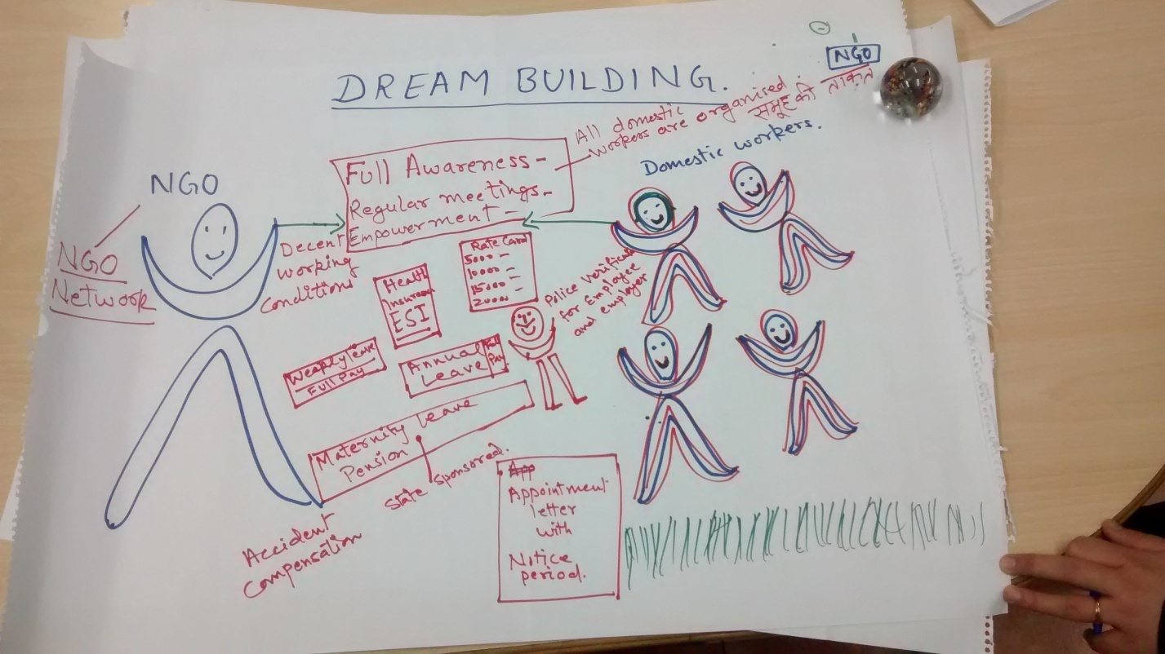 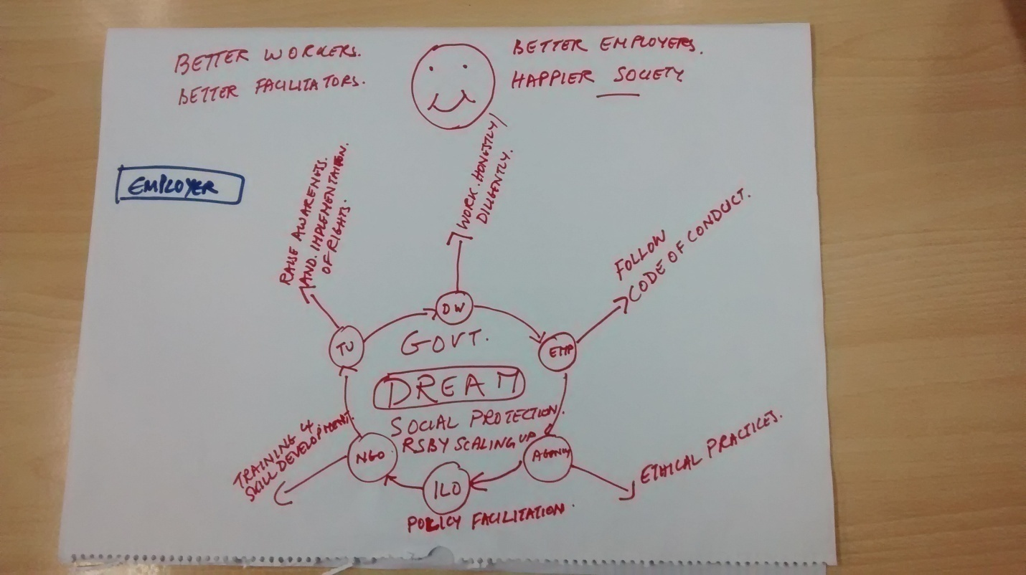

**Dream of the Trade Union Dream of the domestic worker**

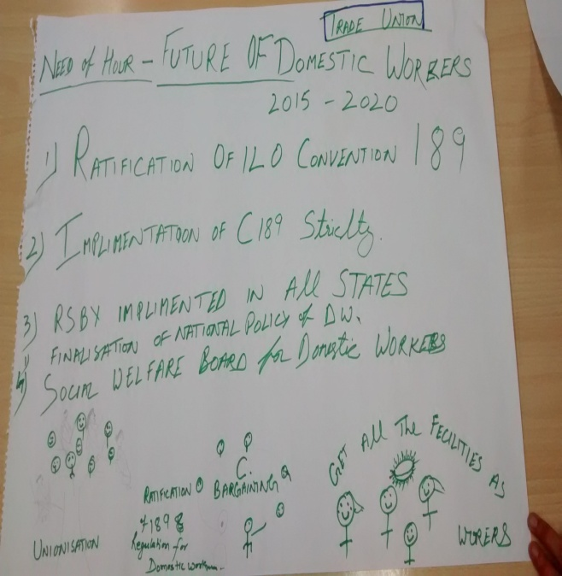 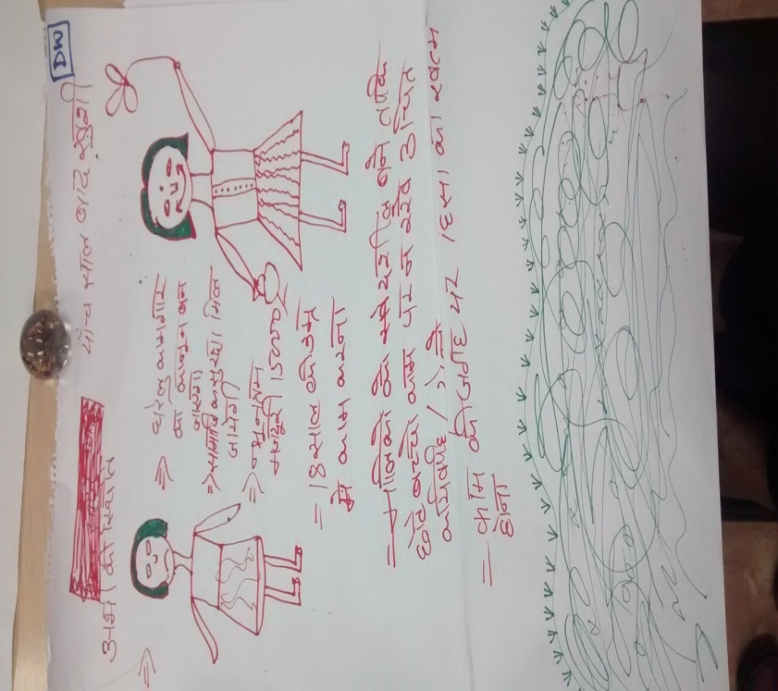

**Dream of the ILO team Dream of domestic workers**

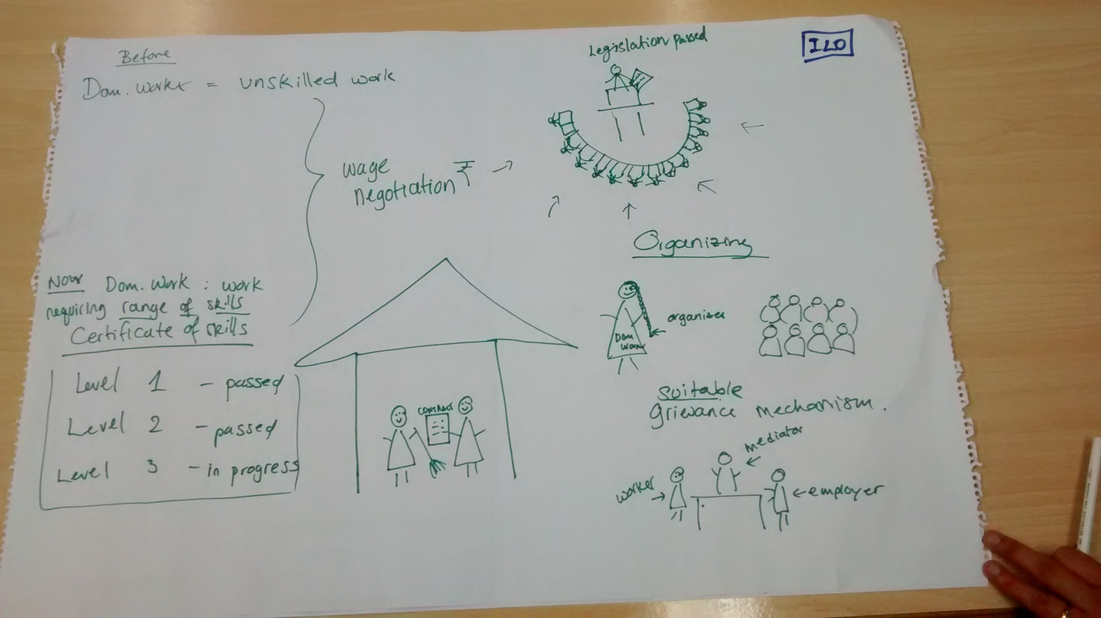 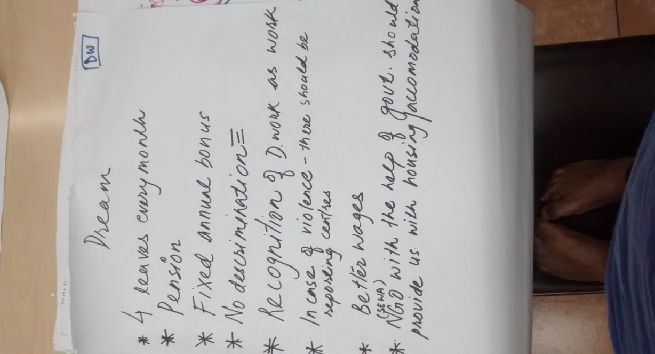

## Synthesized Dream

From the individual dreams of the participants, composite/synthesized dreams were formulated as below:

* All domestic workers are aware of their rights, meet regularly and are collectivized/unionized (esp. migrant workers). They have the ability to join unions and are motivated to get represented.
* Strong NGO network of Domestic Workers and support of ILO.
* Decent working conditions, annual leaves, notice period, weekly off, ID proofs for the domestic workers.
* Police verification of both employer and domestic workers. Appointment letter and contract issued to domestic workers.
* Domestic workers are happy, they take leadership for their own issues (not through unions), collective bargaining.
* ESI, medical insurance, maternity benefits, RSBY, social welfare board for DWs ensured by the government.
* Domestic workers are honest.
* Placement agencies get appropriate commission and are registered.
* Regulation of placement agencies-there should be some mechanism in place to keep a tab on the source and destination of the full time workers/live in workers to counter the problem of trafficking, otherwise it is very difficult to contact them.
* ILO will work on influencing policy-law for the domestic workers.
* Domestic work is included in labour department schedule of employment.
* Ratification and implementation of ILO convention 189.
* Trade Unions working on domestic workers’ rights awareness through meetings and campaigns.
* Domestic workers know where to go for grievances.
* No discrimination at workplace.
* Employers do not employ children below 14 years for domestic work. No child labour.
* Old-age pension.
* Recognition of domestic work as work/skilled work so that the domestic workers are able to negotiate for better wages.
* Wages Rs 15000 per month.
* Rate cards for the domestic workers.
* No verbal abuse/ physical violence.
* Domestic work is valued.

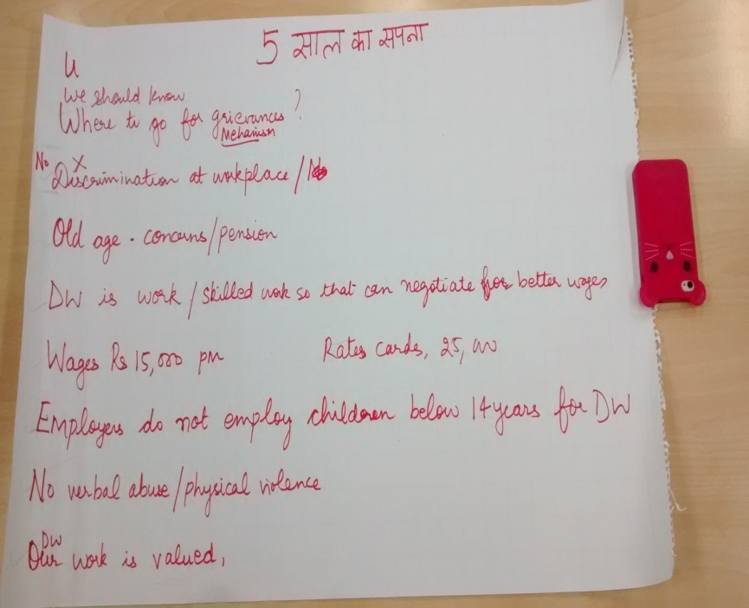 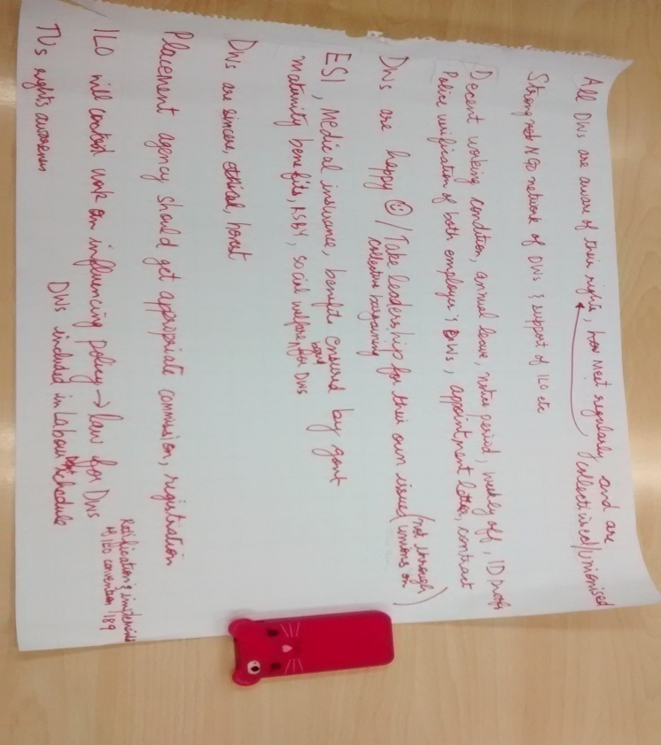

The session ended with this exercise and the discussion on “where we are right now in pursuit of our dream” was scheduled for the next day.

## SALT Visit

In the evening, as part of the workshop, the participants engaged in a SALT visit. The participants were briefed on the purpose of the SALT visit. They were asked to visit other domestic workers in the community, was to appreciate what they have been doing for better working conditions, and their hopes and concerns. The purpose of the exercise was to learn from them and reflect on it the next morning.

They were asked to go there and listen carefully, create an atmosphere where everyone is encouraged and stimulated to share. SALT visits were held the Tigri area in New Delhi, predominantly a slum area. Participants were divided into 5 teams with a facilitator in each from ISST, leading the team. Everyone went there as a person- not as ILO representative, union members, NGO workers- and approached with humbleness, to listen, learn and share and to stimulate them to take action. The teams were asked to reflect within their group after the SALT visit.

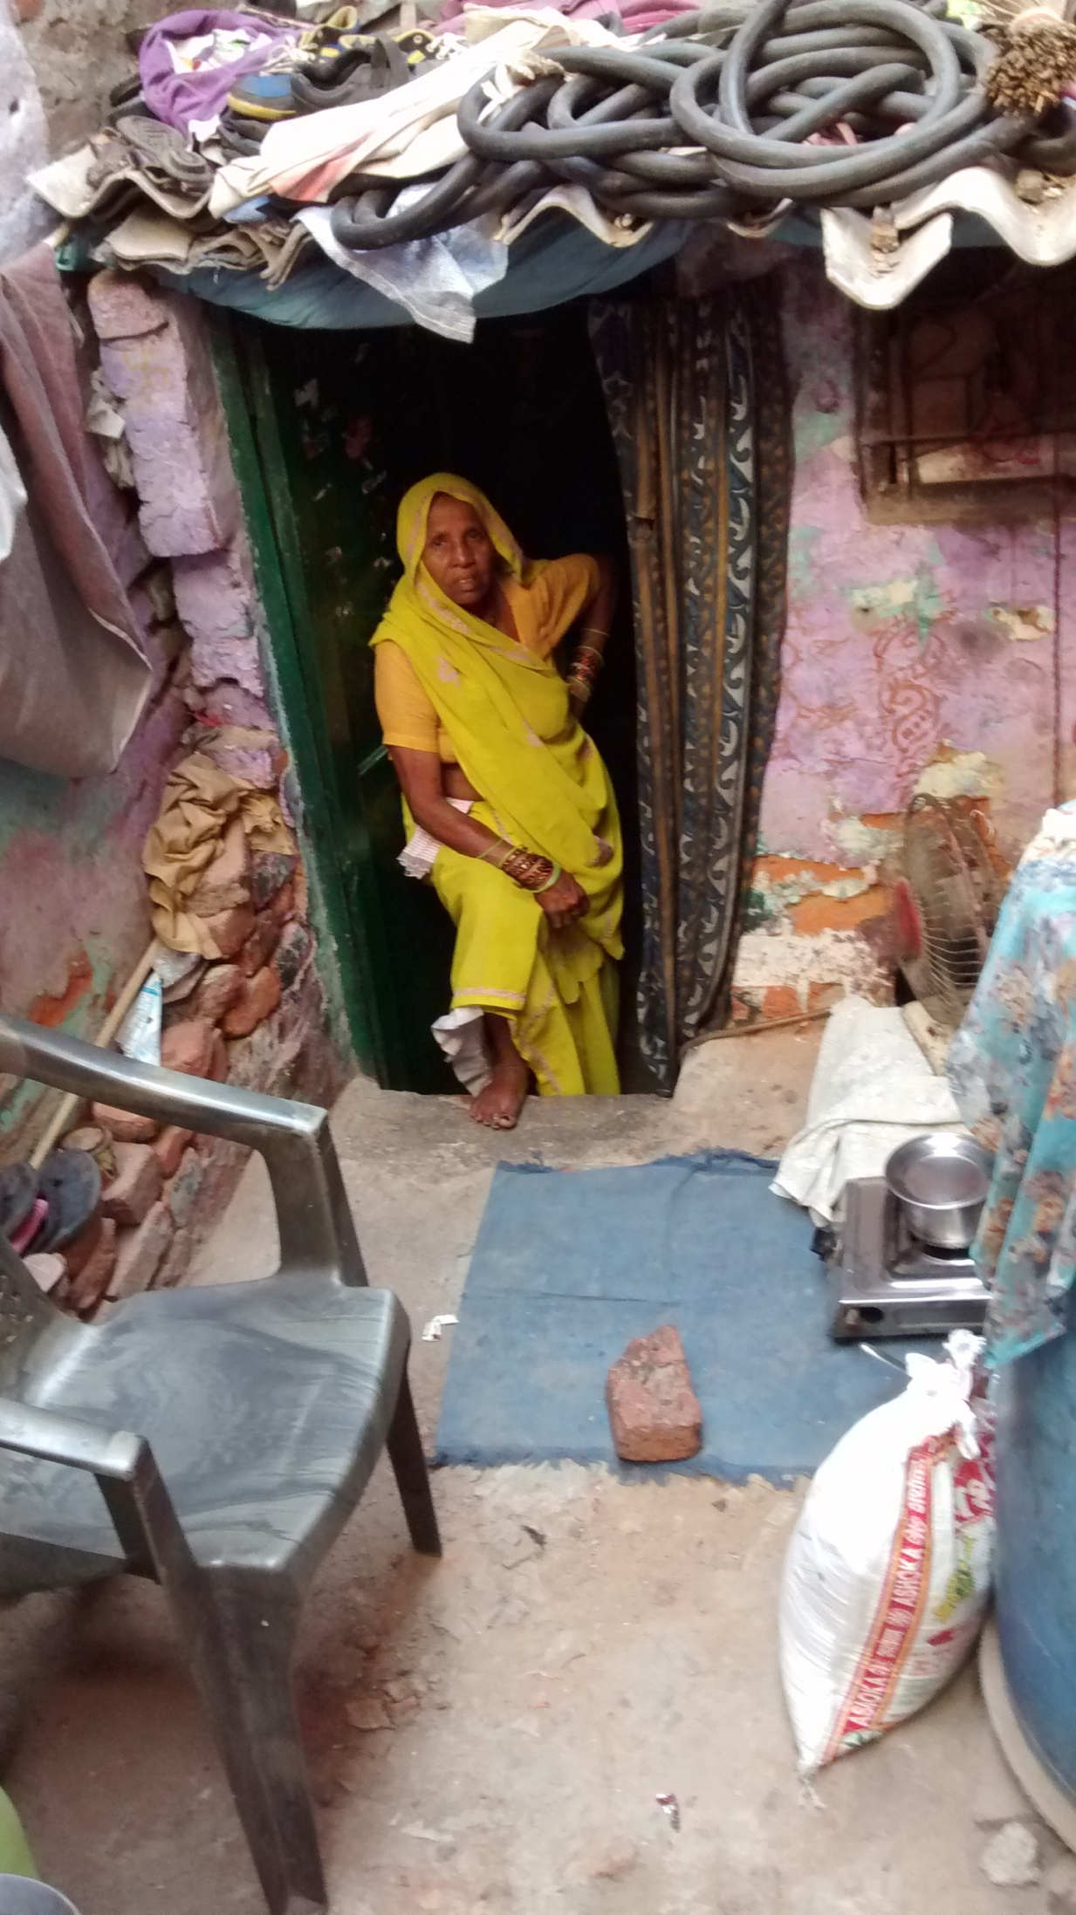

**Day 2**

## Reflections session on previous day’s SALT visit

Each team reflected on previous day’s SALT visit. The teams were asked to reflect on the concerns of the domestic workers arising out of the SALT visit and the strengths they saw in domestic workers. The teams were also asked to make an action plan to address the concerns. The following points emerged.

|  |
| --- |
| **Concerns**   * Most domestic workers are victims of domestic violence. * Houses of the domestic workers are not well constructed. * There is caste/religion based discrimination in the area-.The “valmikis” are not given work , in order to get work they have to lie about their caste/religion. * Domestic workers do not earn enough and have very low or zero savings. * There is job insecurity**.** A participant of the workshop, a domestic worker, shared that she lost her job even on informing the employer that she will not be able to come for work. * Sometimes, there are additional tasks and longer hours of work but no additional pay is given. * Many domestic workers go through mental distress due to which sometimes they want to commit suicide * They lose their job when their place of living (generally illegal colonies are demolished which is quite common and are relocated to another place. * Sexual violence at work place is another area of concern. * Creche facility for the children of domestic workers is absent and where it is available, the cost is too high. * Work-life balance is absent. * Alcoholism and drug abuse is rampant in their locality. Their children fall prey to these anti-social elements. Husbands/male members of the family spend all the money the domestic workers earn leading to financial crisis at home, they beat up their wives aswell. |
| **Strengths**   * Domestic workers are planned and organized, they don’t take unnecessary (weekly offs) leaves and accumulate them for any unforeseen circumstances. * They have the courage to deal with difficult situations, to deal with police etc. * They are very hard-working and have strong determination to do things. * They get their family’s support. One domestic shared that her elder sister looks after her children when she is not home. They get emotional support from their families. * At the local level, the women in the community get together to address their concerns |
| **Action**   * Trade unions-We will support the domestic workers on the issue of having creches for their children. The employers need to be educated on the issues surrounding the domestic workers and the domestic workers need to be aware of their rights. * Counseling sessions for alcohol and drug abuse. * The domestic workers should organize and using their strengths should deal with their problems themselves. |

Details of the SALT visit in annexure 3

# 3: Developing indicators

The synthesized dreams were grouped under 8 broad categories. Grouping the dreams and defining the category was done by the facilitators in discussion with all the participants. This also meant that there was no duplication of individual dreams. The 8 categories that were developed are as under:

1. Grievance mechanism
2. Representation and unionization
3. Recognition of domestic work as work
4. Domestic workers take leadership
5. Policy of legal framework in place
6. Working condition
7. Social security
8. Family and Community support

**Bobby, Facilitator-**What level are we at? What tells you so (Indicators)? Which level do we want to go in the next three months? How do you know that you have reached that level (Indicators for the target level).

All participants were divided into 8 groups and given a practice each (8 practices), they were asked to think of a situation when their dream has been achieved and to give the indicators (how the level has been achieved) for the practice assigned to them. Each group was then asked to pass on the sheet to the next group to read all the indicators and add to the list of the indicators. The process was repeated till the time all groups had the chance to read all the indicators and add their points for all 8 practices. During the discussion the below points emerged.

|  |  |
| --- | --- |
| **Grievance mechanism** | * A help line number in place- working, efficient and pro-active * Contract as a basis of grievance in place * Contract making conditions legally binding on both employer and employee. * A forum/information centre where law related information can be obtained and a centre where domestic workers can go to and talk about their problems and get advice on how the problem should be addressed * A Tripartite domestic workers welfare board-Workers, employers and government * Association of domestic workers which can act as a problem solving platform for the domestic workers * Unity amongst the domestic workers which enables them to fight all problems and to find solutions to their problems-domestic workers |
| **Representation and unionization** | * Domestic workers are aware of their rights, are self confident and have come up together to discuss/address them for better working conditions. * Representation, exploitation free society and all stakeholders are accountable for it * Laws are enforced, laws and regulation binding on all * Awareness of rights and communication * Self confidence and no violence * Creche service * Ease of admission for our children in schools * The law enforcing bodies such as police should understand our issues and rights and also should not harass us for thefts/any other crime we are not part of * There should be unity and the community should take the initiative to hold regular meetings and not wait for any NGO or Trade Union * All domestic workers are unionized. Trade Unions membership is at present limited. In order to unionize more domestic workers, domestic workers themselves need to reach out to others and collectivize them in to unions. * Through the initiative of unions all States to include DW in minimum wage schedule * All domestic workers are members of trade unions and the trade union is being run by Domestic Workers at all levels * Collectivize domestic workers, educate them about importance of trade unions and make them trade union members. * Form small groups and hold regular community meetings * Distribute informational pamphlets/posters for awareness generation * Take ownership of the problems and take action collectively * Form a network with all trade unions and work collectively and build pressure on government to form domestic worker law * Build a relationship with media with help ILO, NGO, Trade union etc * Formation of a committee run by domestic workers and trade union members to deal with problems a domestic worker might face at work relating to leaves, wages, sexual harassment at work place, violence at work place. The committee will also look at the problems domestic workers face at their living place such as caste based discrimination, domestic violence, alcoholism, drug abuse etc. The committee will also create contact with the government departments. |
| **Recognition of domestic work as work** | * Appreciation * Respect * Correct/non-exploitative Salaries/wages * No discrimination * DWs are allowed to use the bathroom at workplace * The employer and employee are able to share problems with each other * Employer helping the employee in case of emergency and problems * DWs get 1 day off every week * 15-30days minimum paid annual leave * Domestic workers are happy * Working hours are fixed * Domestic workers get bonus * DWs get government holidays * Salaries on the basis of type of work and number of hours * Salaries fixed keeping in mind the rate of inflation * Written contract compulsory * Workers promote work ethics among each other * Domestic work recognized as skilled work * Respect for work * Minimum wages for work * No discrimination at work place * Work hours and wages should be decided according to work * Good and cordial relationship between the employer and the employee * Employer and employee should stand for each other in times of need * Skill development training because improved skills will result in better wages * If we improve our skills ,we should be able to save and plan for our family’s future |
| **Domestic Workers take leadership** | * Local area group formed and is operational * The Domestic workers themselves without the help of any NGO or Trade union do regular meetings * DWs find solutions to their problems, fight for their rights * DWs create awareness among other DWs in their neighborhood, motivate them so that in the future they take leadership. * DWs discuss their concerns and problems among themselves and solve their problems and then share their experience with others * Groups at various levels are connected-local micro group and so on * The community takes the initiative to stop alcohol consumption * Domestic workers talk to their employers themselves if they are asked to leave the job for no valid reason and if that is not enough then the DWs take the help of union/association. * Domestic workers are able to decide their salaries * Domestic workers association is able to solve all problems on its own without the help of any NGO * The workers association has the knowledge of the right to information act. * Domestic workers to take leadership in solving their and other domestic workers’ problems on own. |
| **Policy of Legal Framework in Place** | * Recognition and inclusion in government policies, law relating to DWs and their rights are in place and is being followed * The government, domestic workers, ILO, Placement agency, trade union are working together and the government is listening to them and making necessary amendments from time to time in the law. * DWs are able to avail government schemes, policy specifies the contract * DWs get pension through the Domestic workers welfare board * DWs are included in the schedule of employment in all states (It is in place in some states) * Policies, laws, legal framework in place to handle employer-employee (DW) problems, rights etc * Minimum wages notification * Ratification of convention-ILOC-189and is implemented well |
| **Working condition** | * Non exploitative wage rate/wages based on task performed/decent wage for domestic work * Decent working hours, time off and justified holidays * Eligibility and access to employee state insurance (ESI)-card * Understanding between employer and employee about the decent working conditions of the domestic workers * Meetings and sensitization on the rights of domestic workers and also for negotiating for better work conditions by the resident welfare association, NGOs and Trade unions and creation of support groups for the domestic workers. * Placement agencies are registered and are ensuring employer/employee satisfaction, follow ethical practices * The contract is binding on both parties (not necessarily formal but based on understanding) * The contract states leaves, wages are decided on the basis of number of rooms and amount of work, job security, notice period * There is no harassment at workplace * There is love between employer and employee |
| **Social security** | * In case of illness medicines are provided for free or at a subsidized rate * Access and better implementation of Rashtriya Swasthya Bima Yojna(RSBY) * Eligibility and access to Employee State Insurance-ESI * Paid maternity leave is given by the employer (3 months leave) * Creche for 7-8 hours where children are kept while the DWs are away for work, community crèche * Minimum pension amount (maybe after the age of 50) * Monetary compensation in case of illness * Medical benefit on duty * Well informed about the importance of education and are sending children to school, free education for children * Universal coverage of P.F, ESI, Pension and free medical facilities after the retirement age. * Notice period   Benefits that the employer should provide   * Entitlement to leaves in case of emergency * Bonus on festivals like Diwali * Maternity leave for 3 months * For additional work, there should be additional payment   Benefits that the government should provide   * Pension (other pension such as widow pension, old age pension to be facilitated) * Maternity protection * Educational assistance * Accident insurance * Medical cards * Cards to be issued to domestic workers incase they don’t have BPL cards to avail hospital facilities * Identity proof to be issued * Government hospitals, government schools should be improved * Creche facility to be provided * Financial assistance by the government for domestic worker’s children’s marriage * Housing, sanitation, safe drinking water, electricity supply should be provided |
| **Family and Community Support** | * Our family members support us when we go out to work, they don’t stop us from going to work. They take care of children while they are away at work. * People in our neighborhood/community support us when there is a problem. * Balanced distribution of family responsibilities-between husbands and wives in families, husbands showing support towards domestic work done in the house and outside. Other family members also are supportive. * Mental peace-trust between husband and wife (improves quality and productivity of Domestic workers, important for psychological and emotional well-being of women and family) * Harmonious relationship between people within the communities where domestic workers live, cooperation and support given to each other. * No caste based discrimination * Celebrating and sharing with community in times of joy and hardships * Community support to reduce alcohol consumption * Getting together as a community through cultural entertainment, sports and other harmonious activities for better understanding and cooperation. |

## Self assessment: Monitoring and Evaluation

In order to prepare the participants for designing their self assessment framework, some explanations were provided on key concepts. Rituu, lead Facilitator- “To go ahead in life, to do well in life, it is important to dream and it is also important to assess our present condition to reach our dream. We constantly should assess ourselves, see if we are going towards our dream and if not, take corrective action. It will tell us if we are taking the right steps towards the achievement of our goal.”

Rajib Nandi, co-facilitator- “I will share an example with you all. Usha ji (domestic worker, participant of the workshop) told me yesterday that it takes her 30minutes to travel from Tigri to Panchsheel on a cycle. She assesses everyday how much time does it take for her to reach her place of work, she does it so that she can accordingly plan as to when she should leave her house and the mode of transport she should use in order to reach on time and be also able to go to other houses for work on time. If on a day, she is stuck in traffic, she will assess how late will she get for work and accordingly follow a different plan, here she will take a shorter or some other route to reach the destination. Regular assessment is important for taking mid-course corrective actions. “

Thus, to be able to reach to our dream it is important to know what our present situation is and what steps are needed to be taken to reach to our dream. If all groups such as ILO, NGO, Trade Unions, and Placement Agencies do their self assessment individually and as a collective, the assessment will be correct/valuable in the true sense with suggestions for improvement from all.

# 4: Extracting practices of self-assessment from the dreams

Domestic workers were asked to choose three dreams/practices they consider the most important that they think would be achievable in the next three months. The three practices/dreams that were chosen after discussion were:

* Leadership amongst the domestic workers
* Representation and Unionization of domestic workers
* Family and community support

Groups with three people each were formed for rigorous discussion, they were asked to look at these three dreams and write on sheets of paper their current situation and where do they want to go in next six months with regards to each dream. The following points emerged:

## Defining level 5

|  |  |
| --- | --- |
| **Leadership** |  |
| **Where are we now?** | **Where do we want to go in six months?** |
| **Domestic workers**   * Just started joining groups * Around 10-15 women meet but not many * Currently only a few small groups are operational * Dependent on NGOs for organizing and coming together * We have not started having meetings on our own yet | **Domestic workers**   * More number of people in our groups, we want the number to double * Formation of groups at places where they are not present * Will have discussions with our sisters, encourage them to join * Hold meetings every week * Strengthen our group, expand within our locality first and then join groups in other localities |
| **NGO**   * Domestic workers are taking leadership where we are working * Domestic workers take leaves and come, when they are called for meetings, these meetings are conducted by a leader from amongst the domestic workers | **NGO**   * We have only a few leaders at present, will work towards getting more leaders in 6 months |
| **Trade Union**   * Earlier we did not focus on domestic workers, did not work much in the unorganized sector. Trade Unions now realize that the population of domestic workers is large and growing and this an important area of work * Now started to work for domestic workers, trying to connect them to unions * Linking them to unions has benefited them * After becoming union members, they become activists and then start taking leadership * Trade unions are creating awareness to enable the domestic workers to take leadership and are also forming trade committees | **Trade Union**   * Increase in awareness about domestic workers rights * Increase in membership |
| **Employer**   * We understand domestic workers’ situation but can’t say the same for other employers. | **Employer**   * Sensitize other employers * Discussion with RWAs (resident welfare association) for formation of domestic welfare groups |
| **ILO**   * Working with Trade Unions, to get domestic workers into unions * Encouraging domestic workers to take ownership/leadership | **ILO**   * Produce a paper/document on minimum working conditions, what should we negotiate on * Get it published and share it with the domestic workers * We will start working at the community level also, till now we have been only working at the policy and institutional level |

Due to time constraint, few groups were asked to take up the practice –“representation and unionization” and the remaining to take “family and community support” and repeat the above exercise.

|  |  |
| --- | --- |
| **Representation and Unionization** |  |
| **Where are we now?** | **Where do we want to go in six months?** |
| **Domestic worker**   * We don’t have much information regarding the purpose of forming unions and what does it do? | **Domestic worker**   * Will take information from NGOs in the locality |
| **Trade Unions**   * We are preparing leaders, trade committees, holding meetings and spreading awareness * We can’t cover all domestic workers currently | **Trade Unions**   * Conduct surveys to find out the number of domestic workers, surveys have never been conducted before to find out the number of domestic workers and from which area. The purpose is to gradually cover all domestic workers. |

|  |  |
| --- | --- |
|  |  |
| **Family and Community Support** |  |
| **Domestic Workers**   * We get little support from family, that is why we have been able to attend this 2 days workshop * Not all neighbours understand/support us. | **Domestic Workers**   * Those who manipulate our family members, our group will hold discussions with them and address the issues |
| **NGO**   * Not all families support the domestic workers. They let them go out to work but don’t help them with any household chores. * As a result of the above there is double burden on the woman-doing outside work and also doing household chores | **NGO**   * Hold discussions with husbands and children on this issue. |
| **ILO**   * Community level action is not an area we have focused on for our work with domestic workers | **ILO**   * Will focus on issue such as alcoholism and community creches at the community level. |
| **Employer** | **Employer**   * Understand the problems of domestic workers * Sensitize others regarding the concerns of the domestic workers and as a community do something about their problems like in case of illness provide them with medical help etc |

## Final Reflections

The workshop concluded with a session on final reflections by all participants of the workshop. Participants were asked to sit in a circle and think about the two days of the workshop. A quick recap of what happened during the two days of the workshop was done.

**Rituu, lead facilitator**-The workshop started with the exercise –Are we human? And there was consensus over the fact that all are humans whether from NGO or Trade Union or Domestic Workers or ILO, or with different appearance or belonging to different regions/countries and that all have feelings, emotions, strengths and weaknesses. Identifying and appreciating strengths stimulates people to do better. In the process there is learning and when we learn, we share, which results in more learning. All have different strengths and if all work together (ILO, NGO, Domestic Workers, Employers, Trade Unions, Placement Agency) dreams can easily be reached. Yesterday we all realized each other’s strengths and formulated dreams. A community visit was also done, to understand the living conditions of the domestic workers and the situation of their neighborhood. Everyone went to listen, stimulate and appreciate the domestic workers. Reflection on the SALT visit was done on the second day of the workshop .Everyone saw dreams and also assessed the current situation and what steps we will take to reach to our dreams.

The floor then opened for the participants to share their experience

The domestic workers shared that the two day participatory workshop has encouraged them to speak for their rights, to take ownership of their issues and motivated them take actions themselves. Their awareness on issues has increased. In the words of one of the domestic worker- “We heard our sisters speak for two days, we realized their conditions and could relate to them. We have to realize our own potential, the workshop has encouraged us to work towards it.”

I was motivated to think and do better.

They shared that they have realized that they are not alone and there are others who want their better and want a domestic workers law in place. They feel that if all groups come together and demand for their rights, they will sure make an impact on the government and pressurize the state to take action.

“All groups have the same dream but we have to work hard and work as a community to reach our dreams.”

“The workshop has given us the strength to collectivize and take ownership of our issues and work towards it as a community/group.”

“ I had no idea what is going to happen in the two days workshop, but now I know what we have to do about our condition.”

Alcoholism in the families of the domestic workers came out as one of the biggest problem, leading to other problems. They expressed strong commitment to work on this problem in the community.

“We have worked in our community in Vikas Puri through songs, street plays and we have these plays at that time of the day when our husbands, brothers, other family members collect in the market area to drink alcohol. This has curbed the problem to some extent. We have done this in five slum areas. The community also supported us. The liquor shops had to be shut down because of our effort in these 5 slums.”

The employer group shared that it was good to see the domestic workers take out time for themselves and they expressed that the domestic workers should come together and form a community level local group. “Two day workshop compelled us to think about how to maintain the standard of the domestic workers.”

The trade union representatives said that they all have the same dream and that the domestic workers and all other stakeholders together have to work towards it. They shared that the two days workshop brought out their strengths and also weaknesses and the areas where they have to work.

The NGO shared that the workshop platform made them think about the condition of domestic workers, made them listen to domestic workers. “We heard all stakeholders share their thoughts and learnt about the different perspectives.”

“I really liked that we discussed all issues in great detail. I feel enlightened, I learnt a lot. Such workshops should happen regularly.”

**ILO**-“The SALT visit was extremely helpful because as ILO we primarily focus on the working conditions of the domestic workers, work at the policy level but don’t really look at the root area of the difficulties. It helped locate the root cause of the frustration of the domestic workers. The SALT visit enabled us to understand the living condition of the domestic workers. There is a need to link community based action to policy level action, in selective communities, to begin with.”

ILO team shared that the domestic worker’s commitment will encourage them to continue working towards improving domestic workers’ living and working conditions.

**Wanyi ,Singapore, an external participant/observer**- “ I saw everyone is committed and serious about the process. I am very impressed with how the participatory strength based approach enabled all the stakeholders engage together. The resilience and hope that I saw here is very powerful. I hope since everyone is so committed that the dream is fulfilled.”

The facilitators thanked everyone for coming and making the workshop a success. The ISST team and ILO expressed that they are hopeful and feel that solutions to problems of the domestic workers will come out if all work as a collective.

**Workshop Two**

# Developing the self assessment framework and Action Plan

## Background of the workshop

This workshop was a follow up to the workshop held in early June where the participants were introduced to the community life competence process. This workshop focused on developing the self assessment framework which the domestic workers can use to track their progress towards their dream of decent working conditions. Additionally, aim was to facilitate the compilation of action plan by the domestic workers for the next three months.

**Participants**

**Family members join the event!**

Domestic workers from the Tigri and Non-Tigri area, husbands of the domestic workers, trade union, employers, NGO and ILO. One of the domestic workers said that she was very motivated after the last workshop and that she encouraged a large number of domestic workers to attend the domestic workers day on 16th June. Another domestic worker said that she wanted to get her daughter-in-law for the meeting. Two domestic workers got their husbands and one got her young daughter.

The workshop started with a quick recap of the focus points from the last workshop. Dreams of the domestic workers from the last workshop were revisited. Four groups were formed with all types of stakeholders in each group, the four groups were then asked to discuss in groups and define the practices of the dreams so that a common understanding can be arrived at. This would also help to refer back to the practices in the future.

## Revisiting the practices of the domestic workers

Group 1

**Domestic workers and all associated with domestic workers value domestic work as decent work/dignified profession**

* Respect for work
* Minimum wages for work
* No discrimination at work place
* Work hours and wages should be decided according to work
* Good and cordial relationship between the employer and the employee
* Employer and employee should stand for each other in times of need
* Skill development training because improved skills will result in better wages
* If we improve our skills ,we should be able to save and plan for our family’s future

Group 2

**Social security and legal system in place**

Benefits that the employer should provide

* Entitlement to leaves in case of emergency
* Bonus on festivals like Diwali
* Maternity leave for 3 months
* For additional work, there should be additional payment

Benefits that the government should provide

* Pension (other pension such as widow pension, old age pension to be facilitated)
* Maternity protection
* Educational assistance
* Accident insurance
* Medical cards
* Cards to be issued to domestic workers incase they don’t have BPL cards to avail hospital facilities
* Identity proof to be issued
* Government hospitals, government schools should be improved
* Creche facility to be provided
* Financial assistance by the government for domestic worker’s children’s marriage
* Housing, sanitation, safe drinking water, electricity supply should be provided

Group 3

**Domestic workers are member of trade unions and are running the trade unions themselves**

* Trade unions are limited in number, in order to reach a wider group, the domestic workers will reach out for one another, collectivize and unionize, make members. The impact will be higher if domestic workers talk to other domestic workers about becoming trade union members.
* Formation of committees for grievance redressal
* Collectivize domestic workers, educate them about importance of trade unions and make them trade union members.
* Form small groups and hold regular community meetings
* Provide information to domestic workers about domestic workers issues and their rights
* Distribute informational pamphlets/posters for awareness generation
* Take ownership of the problems and take action collectively
* Form a network with all trade unions and work collectively and build pressure on government to form domestic worker law
* Build a relationship with media with help ILO, NGO, Trade union etc
* Formation of a committee run by domestic workers and trade union members to deal with problems a domestic worker might face at work relating to leaves, wages, sexual harassment at work place, violence at work place. The committee will also look at the problems domestic workers face at their living place such as caste based discrimination, domestic violence, alcoholism, drug abuse etc. The committee will also create contact with the government departments.

Group 4

**Leadership and Family-Community support**

* We will form a group and domestic workers with leadership qualities will teach other domestic workers also to come forward and take leadership. NGO is not present all the time, the domestic worker who displays leadership qualities, will help solve problems of other domestic workers, connect with NGOs and discuss problems of domestic workers, they will also collective and unionize all domestic workers.
* Our family members support us when we go out to work, they don’t stop us from going to work. They take care of children while they are away at work.
* People in our neighborhood/community support us when there is a problem.

## Importance of assessment

The participants were asked the below questions:

**Why do you think we are here today? What is objective of this workshop?**

**Lead Facilitator, Rituu**- “We are here with you because we believe that domestic workers are capable and have strengths to find solutions to their problems. When we dream, we should also know if we are putting in right amount of efforts and going in the right direction, towards our dream. How do we assess if we are going in the right direction towards the achievement of our dream? If we want to go point B from A but instead go in the direction of point C, how do we assess if we are going right? Our objective today is to help you find a technique to regularly monitor/assess if you are going right towards the achievement of your dream and in case you are not doing it right, take corrective mid-course actions. “

**Domestic workers**- “During the domestic worker’s week, we shared with other domestic workers whatever we learnt at the last workshop.”

**Facilitator**-“We will remember that we are all human, whether we are domestic workers, NGO people, ILO members , Trade Union representatives and that we all have strengths and weaknesses. When we keep aside our weaknesses and only focus on our strengths, we see more number of strengths and are encouraged/ stimulated to do more and better, get encouragement to try something new. We will also follow SALT , we will practice it with your family, community, other domestic workers .”

**What do we mean by levels?**

What is our dream, where do we want to go- which level are we at?

Level 5 is our dream, we try to assess which level are we at.

One practice exercise was done with the participants to help them understand and define the five levels.

Participants were asked to define their dream for healthy teeth-

|  |  |  |  |  |  |
| --- | --- | --- | --- | --- | --- |
| **Practice** | **Level 1** | **Level 2** | **Level 3** | **Level 4** | **Level 5** |
| Our teeth remain healthy-no cavity, white teeth, no tartar | We know that it is important to brush but don’t know how to brush | We have the knowledge as to how to brush but we don’t brush | We sometimes brush/occasionally | We brush regularly but it has not become a habit | Always brush,  After every meal, no one reminds us to brush we brush as a habit, it becomes a part of life, routine |

The participants were asked to identify which level they are at using the above simple example and to share reasons why they think they are at that particular level. They were asked which level they would want to be at in the next three months and how they would achieve it. What was learnt from the exercise was that it not as important to see at what level one is but the discussion this stimulates in the community. Valuable is collective deliberation on how can one go to the next level, what actions/steps can one take to go to the desired level and how can one also learn from the ones who are at a higher level, closer to the dream. Importance of self-assessment came out clearly from this practice exercise.

## Defining the levels

Similar exercise was performed to establish similar levels for the eight dreams formulated in the last workshop , to determine which level the domestic workers are at? And where do they want to go?

Two groups were formed : a. Domestic workers from the Tigri area ( Place of SALT visit) and b. Domestic workers from other than Tigri area

Other stakeholders - NGO, ILO, Trade Union were asked to observe the two groups doing the exercise. They were asked to practice SALT, not give suggestions, just observe and give their comments later on the whole process. Please see annexure1 for the self-assessment framework on working conditions of part time domestic workers that was developed for the domestic workers

## Which level are we?

The two groups of domestic workers assessed which level they are at and the reasons for it and which level they want to go. Below matrix was formed.

**Tigri Area**

|  |  |  |  |  |  |  |
| --- | --- | --- | --- | --- | --- | --- |
| **Dream** | **Level 1** | **Level 2** | **Level 3** | **Level 4** | **Level 5** | **Which level do you want to go?** |
| 1.We and people associated with us consider domestic work as decent work/dignified profession |  |  |  |  |  | Level 2 |
| 2.Our working condition is decent | Tigri at 1.75 |  |  |  |  | Level 2 |
| 3.We take leadership on our issues relating to decent working conditions | Tigri at 1.75 |  |  |  |  | Level 3 |
| 4. Family and community supports us for the work we do at home and outside |  |  |  |  |  | Level 3.5  More people will be supporting us |
| 5. We are members of trade unions and run them on our own |  |  |  |  |  | Level 2  We take information about trade unions and decide whether we want to be form trade unions or just form our own groups. |
| 6. We have a redressal mechanism in place |  |  |  |  |  | Level 2  Will acquire knowledge |
| 7. We get social security benefits |  |  |  |  |  | Level 2 |
| 8. Legal framework for domestic workers is in place |  |  |  |  |  | Level 1.5  Will take information about the legal system for domestic |

**Non-Tigri**

|  |  |  |  |  |  |  |
| --- | --- | --- | --- | --- | --- | --- |
| **Dream** | **Level 1** | **Level 2** | **Level 3** | **Level 4** | **Level 5** | **Which level do you want to go?** |
| 1.We and people associated with us consider domestic work as decent work/dignified profession |  |  |  |  |  | Level 2- discussions and meetings around the issue and at level 2 awareness level will be higher and all stakeholders will recognize DW as work |
| 2.Our working condition is decent |  |  |  |  |  | Level 1.5 –We will discuss with the employer regarding the leave and we expect we will be entitled to take leave |
| 3.We take leadership on our issues relating to decent working conditions |  |  |  |  |  | Level 3.25- Include those who are not part of the group, they will be more regular |
| 4. Family and community supports us for the work we do at home and outside |  |  |  |  |  | Level 3.25- They will form groups and encourage people to join groups |
| 5. We are members of trade unions and run them on our own |  |  |  |  |  | Level 3.5- Include more people in the group, will get more members |
| 6. We have a redressal mechanism in place |  |  |  |  |  | Level 2-Will take information to how take it forward |
| 7. We get social security benefits |  |  |  |  |  | Level 2  We will take more information |
| 8. Legal framework for domestic workers is in place |  |  |  |  |  | Level 1.5 |

**Why at the present level?**

The two groups gave the below reasons

**Tigri**

**1. We and the people associated with us consider domestic work as decent work/dignified profession**: The group said that some people in their neighborhood refuse to recognize them in public places because of the work they do.

**2. Our working condition is decent**: They have knowledge on what decent working conditions entail but they do not know what action they need to take towards realizing it. They shared that a few employers understand and provide decent work conditions. “I am aware of decent working conditions and through negotiation could bargain over leaves. My employer also understood me.” But they said not all are able to do the same.

**3. We take leadership on issues related to our decent working conditions**: The group said that they can’t take leadership decisions alone, they have the knowledge to form groups and are trying but without any support from a trade union/NGO are unable to do so. **Suggestion from Non-Tigri group**-“Form a group, each one should try to get people and fix dates/days to meet regularly. We should all meet (tigri and non-tigri group) for atleast 1 hour.”

**4. Family and community are supportive of our work at home and outside**: The group shared that some of the families and neighbours are supportive but not all.

**5. We are members of trade unions and run them on our own**: They don’t have full knowledge of what a trade union is and how it functions and are not part of any trade union. **Suggestion from the Non-Tigri group**: Meet the non Tigri team and acquire knowledge on what a trade union is and how does it function

**6. We have a redressal mechanism in place**: The group said that they know of the importance of a sound redressal mechanism but don’t know the ‘how to’ of it.

**7. We get social security benefits**: The group had knowledge of the importance of social security benefits but didn’t know how to get it

**8. Legal framework for domestic workers is in place**: The DWs said that they know the importance of a legal system but it is not in place and they do not have the knowledge on how to pursue it.

**Non-Tigri**

**1. We and people associated with us consider domestic work as decent work/dignified profession:** The group shared that only a few people recognize their work as work.

**2. Our working condition is decent:** It was shared that there is no rule for leave, if they reach late the employer is unhappy, behavior is not good. Duration of work not fixed.

**3. We take leadership on our issues relating to decent working conditions:** The DWs said that they are organized from Dwarka and they call meetings once a week. They decide the place for meetings and discuss the grievances amongst themselves but not all domestic workers in the area are organized

**4. Family and community supports us for the work we do at home and outside**: The families understand and support them but the community doesn’t understand the issues and also not all families are at the same level

**5. We are members of trade unions and run them on our own**: They shared that they are part of Delhi domestic workers organization, they have a secretary and board members, currently 54000 members. They have not reached all people.

**6. We have a redressal mechanism in place**: They know the importance but don’t know how to do it

**7. We get social security benefits**: They have the knowledge of social security benefits but are not getting any benefits.

**8. Legal framework for domestic workers is in place:** They know the importance of a legal system but it is not in place and they do not have the knowledge to pursue it

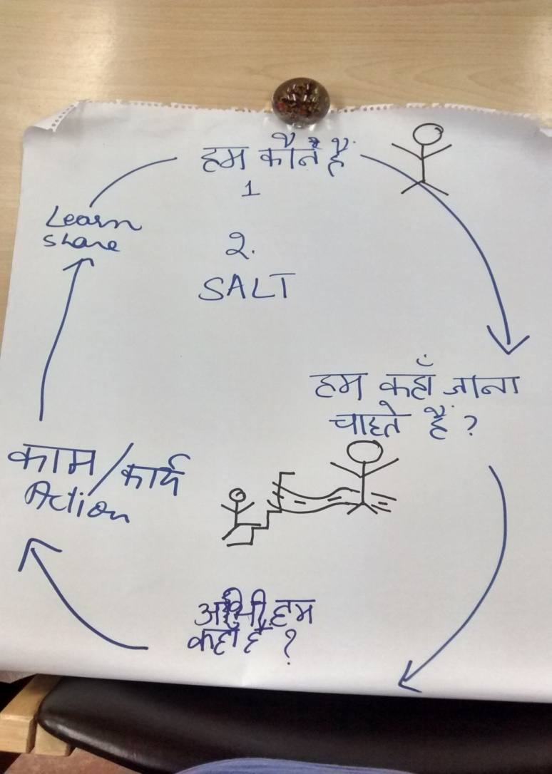 “Through the above exercise, we did our own self- assessment. We got to know our strengths and weaknesses through self-assessment, an outsider can never know more about us , than we know about our own self.”-Domestic Worker

“We could talk about our strengths and weaknesses with everyone easily and understood that if we don’t truthfully talk about our present condition, we can’t reach to our dream” -Domestic Worker

“Everyone is supporting us here, there is feeling of love and oneness”

## Observations by the stakeholders on the self assessment process (NGO, Trade Union, ILO, Families)

* Even if there were disagreements in the group over which level they are at, a middle way through conversations was reached out for all 8 indicators.
* I saw leadership qualities in some of the domestic workers, when no one was able to come out with any point, someone was always initiating the conversation and stimulating others to think and share.
* Both the groups were truthfully talking about their present condition and with everyone’s agreement were deciding the level at which they are.
* It is important to build close/family like relationship with each other for the truth to come out.
* The change I see from the last workshop is that the domestic workers have now opened up and are putting their issues/concerns/stories forward, they are thinking and taking ownership of their issues.
* All domestic workers in both the groups contributed to the discussion, everyone got a chance to speak.

**What will the stakeholders do next time?**

* We will repeat this entire process in Tamil Nadu-ILO.

# 5: Where do we want to go in three months? Developing action plan on two key practices

Out of the eight practices, each group was asked to choose 2 priority practices and action they think they will be able to take in next three months.

**Tigri Area**

|  |  |  |  |  |  |  |  |  |
| --- | --- | --- | --- | --- | --- | --- | --- | --- |
| **Practice** | **Current level** | **Target Level** | **Activities** | **Indicators** | **Who is responsible?** | **When** | **Resource** | **Support** |
| Family and Community support | 3 | 3.5 | We will fix meetings once a month and also fix the time for the meeting preferably from 3 to 4. We will find strengths of the group members during our meetings. | We take down the minutes of the meetings, record everything and prepare an agenda for the meeting | 2 people will be made responsible for this work, everyone in the group will be given some task to do. | Every Sunday | Community Place | National Domestic Welfare Movement (NDWM) |
| We have a redressal mechanism in place | 1 | 2 | We will listen and learn, we will find solutions to our problems using SALT technique , we will talk to people about their strengths | Record the problem | Usha and MirJahan | As needed | We will be responsible for everything | NDWM |

**Non-Tigri Area**

|  |  |  |  |  |  |  |  |
| --- | --- | --- | --- | --- | --- | --- | --- |
| **Practice** | **Current level** | **Target Level** | **Activities** | **Who is responsible** | **When** | **Resource** | **Support** |
| We take leadership on our issues relating to decent working conditions | 3 | 3.2 | Uttara Ji will do SALT visits in her area that is new Ashok Nagar  Discussion about SALT  Will do SALT visits in new areas such as Vikas Puri  Celebrate festivals together | Uttara Maxima, Anita, Pooja, Ruksana, Jaya and Bharti | June 25th, July, August and September | Paper, pen, pamphlets and rented mats | SEWA, DWFF, GKS (gurgaon), DGKS and ILO |
| Family and community support us | 3 | 3.5 | Salt Visit in our area | Sangeeta and Ruksaana | Once a month | Time and information |  |

## What did we learn today?

All participants in groups of two were asked to discuss and share with all the learning from the workshop. Following points emerged out of the discussion:

* We now know what we have to do.
* We learnt how to do our self-assessment, assess which level we are at and where do we want to go and whether or not, we are going in the right direction.
* I will go to my community and share the process. I will now connect with people, listen to them, learn and share.
* Self-esteem of the domestic workers has grown. They are now thinking.- Employer
* I have learnt if we work together we can reach our dream.
* We have to learn from others, we have to listen and learn.
* We never thought we can do anything in three month’s time, but now we are positive that we can achieve what we have planned for three months.
* We can solve our own problems

ISST and ILO team thanked everyone for actively participating in the workshop and making it a success.

A follow up workshop after three months will be conducted. –Suneetha, ILO

## SALT visit to Tigri area

All the participants left for a SALT visit to Tigri area after the workshop. (see annexure 3 for details)

# Annexure 1: List of participants

**List of participants – to be given by ILO**

# Annexure 2: Agenda

**Agenda: 6th and 7th June**

|  |  |  |
| --- | --- | --- |
| Session | Process | Facilitator |
| 6th June 2015 | | |
| 9:30 am | Welcome | Rajib |
| What makes us human?  9:35 am to 10:00 am | We need three volunteers from the participants, one participant will be asked to lie down on sheets of paper and the other participants will draw a body outline of this person.  All participants will be put in pairs and asked to think and discuss in pairs what makes them human.  Discussion and Conclusion  (keep the flip chart prepared ) | Rituu and Rajib |
| Stories Exercise to bring out strengths  10 am to 10:45 am | In groups of 4 each (mixed group) one person will tell a story of what he or she is proud of. Give 10 minutes to share the story. Try that at least one person representing placement agency, NGO and employer share their story  After they have told the stories, then ask others in the team to identify one or two strengths of that person.  Ask 2-3 stories in the plenary. Ask both the story teller and the group members how they felt.  Facilitator to conclude-what happens when we listen to and appreciate each other? What strengths did we hear?  ((keep the flip chart prepared with strengths and keep images handy of helpful, kind, caring etc) | Rituu and Bobby |
| Hopes and concerns  10:45 am-11:15 am | All participants will be asked to share their hopes and concerns with regard to domestic work | Bobby |
|  |  |  |
| 11:15 am -11:30 am Tea | | |
| Agenda of the day and Introduction to Constellation 11:30 am to 11:40 am |  | Rituu |
| CLCP cycle 11:40 am-12 pm | (keep the flip chart ready; find images or drawings) | Bobby |
| SALT  12 pm -1:00 pm |  | Bobby |
| 1:00 pm to 1:45 pm lunch | | |
| Dream Building  1:45 pm to 3:00 pm | Divide the groups according   to different categories and try that we club the domestic workers according to geographical areas  Why do we dream?  What is our dream in our own spheres of action? (What changes would you like to see 5 years from now?)  How do you know that you have reached there? *(here, we are looking for community named indicators of change)* | Bobby with support from Rituu |
| 3:00 pm to 3:15 pm Tea | | |
| Briefing on SALT visit 3:15 pm to 3:30 pm | Purpose of the visit. *(that we are visiting people in their living reality to appreciate their strengths and relate to their concerns)*  How to facilitate SALT visit  Questions for AAR   * What strengths of DW’s did we see in the people and living reality where we visited? How are they using these strengths to optimize for fair working conditions for DW’s? * What concerns related to DW’s did we hear?  |  |  |  | | --- | --- | --- | | Concerns | Strengths | Opportunities for action & change | |  |  |  | | Bobby and someone from ILO |
| 7th June 2015 | | |
| Agenda for the day and Reflections on previous day’s SALT visit 9:30 to 9:45 am | Ask reflections in the plenary. Take detailed notes of the reflections | Rituu |
| What do we understand by Monitoring and Evaluation? 9:45 am to 10:15 am |  | Rajib |
|  |  |  |
| Extracting practices of Self assessment from the dreams 10:15 am to 11:00 am  Define level 5 for these dreams |  | Rituu, Tanisha, Shiny |
| What level are we? What tells you so (Indicators)?  Which level do we want to go in the next three months? How do you know that you have reached that level ( Indicators for the target level) If there is time, we should try and develop indicators for all levels.  11:00 am to 1 pm with tea at 11:15 am to 11:30 am |  | Rituu |
| **Lunch 1 pm to 1:45 pm** | | |
| Action planning and developing indicators  1:45 pm- 3 pm |  | Bobby and Rajib |
| What next? 3 pm to 3:15 pm |  | Rajib and ILO and community members |
| Final reflections 3:15 pm to 3:30 pm |  | Bobby |

**Agenda: Community life competence workshop, 21st June**

Facilitated by ISST

Organized by ILO, Delhi

21st July 2015, IHC

**Objective of the workshop**: Develop and test the self-assessment tool for domestic workers

**Participants**: DWs, families, ILO, two NGOs, employers

**Agenda items**

* Revisit the dream of the domestic workers
* Importance of assessment
* Finalise the practices of the self assessment framework
* What do we mean by levels?
* Defining the levels
* Which level are we?
* Where do we want to go in three months?
* Develop action plan on two key practices
* Next steps

3:30 pm – Departure for SALT visit to Tigri to explore how the practices of self-assessment happen in reality.

# Annexure 3: Salt Visit

**6th June, Tigri, New Delhi**

**Team Facilitator-Shiny Saha**

I visited the house of a domestic worker in Tigri who was also a participant of our workshop. I was accompanied by 3 other participants from the workshop – 2 domestic workers from Ashok Vihar and 1 NGO worker, who works in Tigri itself.

The domestic worker whose house we visited lives in a 1 room set with 3 sons and 1 daughter. Earlier there were 7 members staying in the house - her husband passed away a few years ago and her older daughter has got married.

We discussed the challenges of being a domestic worker. All the three domestic workers complained of discrimination by the employers. They complained that employers try to dispose off their stale (food kept in the fridge for days) or unwanted food by giving it to the domestic workers. They added that employers don’t give the minimum respect that domestic workers deserve as human beings. All three stated that they might be poor but they eat fresh food and so refuse whenever they are offered such food. (Refusing such food, one can argue, reflects resistance to discrimination or as an effort to maintain the dignity of labour.) They, however, added that it is a different matter if employers share the same food as they themselves eat.

The domestic workers also reflected on issues of insecurity. They stated that falling sick is the worst thing that can happen to a domestic worker. The problem is because they as domestic workers are replaceable and there is lack of any compulsion on the employer to hold the position for them. Falling sick results in loss of employment and further impoverishes them as there is no social security to cover for medical bills.

They further noted the lack of understanding, faith and compassion on part of the employer, especially with regard to them taking leave. All stated that employers refuse to believe when they have to take leaves out of compulsion. Employers accuse them of making excuses. Further, they added that whenever they have informed their employers beforehand (the day before) that they would be taking leave, employers have tried to exploit the situation to their own advantage. Employers not only make them finish the work that would have otherwise remained pending on account of them taking leave, but also use it as an opportunity to get additional work done.

They add that employers exploit not only by denying the agreed upon number of leaves but also by adding tasks to the agreed upon number of tasks. They state that while the payment remains the same, the tasks keep on increasing. One of them adds, “we as human beings, at times, think of our employers’ problems/ challenges and do the extra task without complaining. But this relation of compassion and understanding is not mutual as the employers refuse to acknowledge our problems and are ever ready to exploit.” Thus, they add that they are left with no choice but either to lie or to not inform before taking leave/s. (The lady whose house we were at stated to have made the excuse of going out of town – Agra- in order to be able to take leave to attend the 2 day workshop).

The NGO worker intervened at this moment by stating how employers rely on the services of their domestic workers to get on with their daily schedule. Not informing them, thus, does not only create problem for them (the employers’) but also adds to their apathy towards the problems of domestic workers. So she suggested that the domestic workers should inform their employers in the morning if they are taking leave/s. This way not only would they be able to avoid the exploitative situation wherein the employers make them do extra work on account of them going on leave, but also keep the employers informed in order for them to be able to plan their day accordingly. She adds that professionalism has to come from both ends in order for mutual understanding.

On being asked if they provide replacements to cover for them while they go on leave, they state that it depends on the employer. Some employers appoint replacements on their own as, they state, they are suspicious of the replacements provided by them. One of them shared her experience of how, on having appointed a replacement, the employer had warned her that if anything would go wrong they would come after her (the permanent domestic worker).

One of the domestic workers from Ashok Vihar also spoke of insecurity resulting from staying in a rental accommodation. The other domestic workers agreed to this and added that they were grateful for having their own house to stay. They added, “You might not have money to pay for food but you sure have to have money to pay rent.” The domestic worker staying in the rental accommodation shared that with her husband having passed away (four months before the visit) and with rent to pay, she has not been able to send her daughter to school.

Further, the domestic workers discussed the plight of full time domestic workers stating that they are the most exploited – are denied proper food, not paid and are also subject to physical violence.

All the three domestic workers present for the discussion were found to be engaged in alternate occupations. The lady whose house we were at reported to also work as a masseuse. While the domestic workers from Ashok Vihar reported to work as roti-makers in weddings and other events.

They expressed the desire to have fixed number of leaves and also social security, especially pension. They also added the need for police verification of the place of work – who guarantees the place of work.

(This SALT visit had to be cut short as the domestic workers from Ashok Vihar were getting late and had a long way to go home.)

**Team Facilitator-Tanisha Jugran**

I went to Mir Jahan’s place for the SALT visit on 6th June. Mir Jahan is a domestic worker, the other people in the group were domestic workers from West Delhi area and one NGO worker.

Aarti, domestic worker from Dwarka area stated that she leaves her kid with her mother while at work and when her mother is away, she has no other option but to leave the kid with some neighbour. “We leave our kids with someone at home or alone at home, when we go out for work. We need creches, we totally forgot to discuss about creches during the workshop.” The group also expressed concern over the fact that they are not allowed to use the toilets at their work place. There are some restricted areas in the house for them and they cannot touch certain things in the house “ If we want to use the toilet at the place of our work ,we can’t, we again spend money on the transport to come back home to use the toilet.”

“ There is discrimination at the work place , the employers ask if we are Muslims or Hindus before hiring us for work. The “Valmikis” , hide their caste, they say that they are “Thakurs” to get work but are thrown out of work once their caste/religion is known.”

Mir Jahan- “I once got a neighbour , a job at someone’s house, on realizing that her husband is a garbage picker and a valmiki, the employer threw her out of the job.”

“We are illiterate and can’t do any other work, we need money for our children.”

Domestic worker of the West Delhi area- “I am associated with an organization since 1992 which has been working with domestic workers for their rights but did not know how many similar groups were doing same kind of work, through this workshop we got to know about the different groups working for us. We have realized through the workshop that if all stakeholders, all groups work together, as a collective, we can definitely put pressure on the government to take action .Individually we will not be able to take things to a bigger level, collective effort will help us reach to our goal.”.

Identity cards for the domestic workers are important said the NGO worker.” There should be identity cards, if something happens to the Domestic worker at work place or otherwise, the group they are associated with can help them take action. There should be some sort of document for the employers to fill which gives information that the domestic worker is working for them, type of work being done and the salary being paid.”

“The police does not listen to us, they say that we only would have done wrong and refuse to register our complaints.” –Domestic worker

A domestic worker from Ashok Nagar area shared that she cooks at 4-5 houses, leaves her house at 6 30 am and comes back at 2pm. She then again leaves at 6 30 in the evening and is not able to come back home before 9 or 10 in the night. She further added that she cooks for around 8 people and makes 50 rotis/Indian breads a day at one of the houses, she gets the same money for cooking food for 8 people in one house and for 4 in another.” The Salaries are not fixed on the amount and kind of work we do.”

“Earlier when I came to Delhi for work I could take 2 leaves every month, now that has increased to 3 through negotiation.”

“We should inform our employers before taking leaves and when we are sick, the employer should give us leave, we cannot do quality work when we are sick.”

The domestic workers added that their relationship between the employer and the employee is based on the number and frequency of leaves taken by them. They agreed that skill development is important for their growth.

What came up from the discussion was that there is lack of trust shown by the employers towards the domestic workers. A domestic worker told, how she was held responsible when Rs50,000 cash went missing from a house she was working at. She said, she was not afraid of anything but was heartbroken because without any investigation she was blamed for stealing the money. Later on it was found that she was not responsible for the theft and was called back to work .She refused to go back to that house saying that the most important thing for her is her self-respect and people who don’t respect her and her profession, she has nothing to do with them.

Another story came up, shared by the NGO worker where a domestic worker from Orissa was thrown out of work without being paid her salary. The NGO intervened and the employers had to pay her. He stated how important it is for the domestic workers to collectivize and unionize.

Aarti-“No one wants to listen to us and about our problems , what I liked about the workshop was that people heard us. People are thinking about us at the policy level. We opened up and shared freely.”

**Team Facilitator-Rajib Nandi**

Team members: Usha (domestic worker), Rajib (ISST),Vidya Sagar Giri (AITUC), One Bengali domestic worker from Dwarka, placement agency representative

The first SALT visit to Tigri was made on 6th of June. The team visited Usha’jis house and also met four more domestic workers, who gathered at Usha’s house on that day including her sister. She is also a domestic worker and lives in the same locality.

Usha presents herself as a Balmik person. Balmiks belong to a dalit community of Northern India. She reported that many of her neighbours in her locality are Balmiks by caste. She told, the employers often ask the caste at the time of appointment and when they come to know the caste status of the domestic worker, they set “do’s” and “don’ts” for the domestic worker, with regards to their movement inside the household, using/touching the household items particularly in the kitchen area. Usha’ji complained that this inquiry about their caste and then the follow-up reaction is very debasing. It brings down the moral and self esteem of the domestic worker.

Usha has three sons, living with their families live in the same house. All three daughter-in-laws used to work as domestic workers earlier but now they discontinued their work as no one is there to take care of the children in the family. The youngest daughter-in-law especially mentioned the lack of child care service in the locality where she can keep her young son and re-join the workforce. She is keen in joining back as domestic worker, but unable to do so as there is no crèche facility.

Three of Usha’s sons work as wall-painters. They earn good money and contribute to the family income. Usha presently works only in one household in the Panchsheel area, where she has been working for last 17 years. Usha does not complaint much about her employer, as they donated many household stuff to Usha including a window AC and several crockery sets. Usha is happy where she is working and would like to continue at the same place as long as she is able to work.

We met three/four of Usha’s neighbours. All of them work in two to three households in the area called Panchsheel. They prefer to go to Panchsheel, as the wage is better in that locality.”People with big houses stay there, it is far from our locality but we get good wages.” It takes 30 minutes to reach there by cycle.

But the picture is not entirely optimistic for everyone. One said, “ There is always the risk of losing job, if we to take longer leave on health grounds”. They generally don’t get back the same job once they return from long sickness.

They cannot go on leave and visit their natal home if outside Delhi in fear of losing their job.. Some employers understand the problems of the domestic workers but most are totally insensitive and don’t care about the health or lives of the domestic workers.

The domestic workers do not expect any medical support from the employers. However, sometime some of the employers give them some medicine, and Rs.100 / Rs. 50 for treatment, but this is very adhoc. One said, “We don’t have time to stand in the queue of the public hospitals and neither can we afford private hospitals. So, we go to local doctors in the locality.

Family understands the limitations but their cooperation is also to a limited level only. Not all of them understand that we also work to earn money to run the family. One said, “when the husbands come back home in the evening, they say they are tired and expect their wives to cook for them in addition to taking care of the children, but we too are tired, but never expect our husbands to cook and feed us.” A few are lucky, at least their husbands take care of the children while cooking or doing other household chores. “We also need some time to relax, we also like to spend some time with our neighbours to chat. It is easy for the men , they just go out in the evening and spend time with their friends and comeback home when the food is ready to be served”

Neighbours generally look down upon domestic work. They do not value domestic work as it is a low paying job. “But the good thing is that, some of them now have started understanding the value of this work, they give a bit of respect:, Usha adds, “My sons know, how I’ve raised them , how they will ignore this?

There is drinking problem among the men in the community and the problem of domestic violence. One of Usha’s neighbour admits that her husband beats her up once in a while.

When husbands are sick, entire responsibility comes on the woman, irrespective of her own physical status or health condition. “No one ask us about our health. We feed our family from this low paid job, but even in such situation, when we feed our families, take all responsibilities, neighbours say,” This woman goes out to work”, as if we are doing some illegal job. “Due respect from the community is yet to be received”, added Usha’s sister.

Alcoholism is a real problem in the community. It is the root cause of lot of disturbances in the colony. Fights and gambling in the area are also on rise. A number of local liquor shops have come up in the recent time with support from the dishonest policemen. This has lead to bad impact on the young generation , one said during the discussion.

One neighbor said that her husband spends almost entirely on drinking and do not contribute much for the day to day expenses. However, she praised her husband at the same time for subscribing to, two Life Insurance Policies in her name, for which he pays the premium. Her husband is a government employee with the MCD.

“We don’t know what will happen when we won’t be able to work, don’t know who will take care of us when we’ll grow old. We don’t have any insurance, no pension nothing.” They feel, the government must do something about this problem.

Usha’ji is hopeful. She wants to make a small group of domestic workers from her own locality. She wants to start an anti-alcohol drive in the area.

**SALT Visit, 21st June**

After the workshop on 21st June, the participants were divided into four groups lead by a facilitator from the ISST team and ILO team. The teams went to the Tigri area , New Delhi, predominantly a slum area, place of residence of the domestic workers. The aim of the SALT visit was to stimulate the domestic workers to share, appreciate them about their strengths, to learn from them and to share the learning with all.

**Team facilitator: Shiny Saha**

For the SALT visit on 21st June 2015, I went to Usha Ji’s neighbour’s house. The visit at Usha ji’s house on the 6th of June had been facilitated by Rajib Sir.

Usha ji’s neighbour is a domestic worker but has not been working since a year as she is recovering from a hand injury. She plans to join soon on recovering from her injury. Her ex-employer has told her to visit her when she has recovered and is ready to re-join. She lives with her husband and two sons (both of marriageable age, as described by her).

Lack of job security, according to her, is the biggest challenge with respect to domestic work. She says, “there is no guarantee in this work; it is fine as long as we are fine (health wise).” She summarizes the situation as, ‘no health implies no work’. Further she adds that she did not and does not expect anything from her employers in terms of medical support. ‘We are however grateful if our employers help us in our hour of need’, she adds.

In terms of community and family support, she says that the community spirit is missing in today’s world. She states that now a days neighbours don’t support each other on anything. However, different castes cohabit in her settlement and there is no caste based discrimination. As had emerged during the workshop, she too states alcoholism (among men) as a big problem in the area, in which her husband and sons also regularly indulge in. As per participants from the settlement present during this SALT visit, 99% of the men in the settlement have this problem.

In terms of how alcoholism affects her family she states that not only is it a waste of money but is also a big source of worry - one is also constantly worried if the family members are getting into fights and creating trouble. She adds that her sons don’t financially support the family. She has tried to reason with her sons (she believes her husband is beyond reasoning) but to no avail.

In her words, “the rich are better off than us because the husbands support their wives, whereas ours don’t.” She adds that her life revolves around her house and work: she works only to contribute to the household income.

She adds that the young wives in the settlement have a very tough life as they don’t have their husbands’ (who are busy drinking) support and have to also raise children. She says that some people believe that marriage is a cure for all problems – even for alcoholism. However it doesn’t, in fact it ruins the young wife’s situation, she adds. Women of her age, she states, know how to deal with such a situation. So, she argues, she has not got her sons married yet. She states that she is worried that post marriage they (the sons) might start drinking more, and that would just ruin their young wives’ life. This she says would not be fair to them.

Further she adds that as a working woman she has double burden – she has to work at home and also at her place of work. On her part she states that she tries to maintain timings at work. However, she has to make excuses to take leave/s even if she and her employer have come to an agreement on the number of leaves. She adds that taking leave/s, however, also result in double work for her as her employer leaves the pending work for her to finish when she rejoins (instead of doing it on her own). Some employers, she states, don’t want to understand our - domestic workers’ - problems.

At this point the other participants of the group – comprising of Usha ji, 2 other domestic workers, 1 NGO representative – started explaining the purpose of the 3 days of workshop and our visit. They highlighted the need and importance of meeting regularly, sharing each other’s problems and collectively devise ways of dealing with the same. The need to realize one’s own potential (without the support of others) was given emphasis. Planning ensued on when to meet (Sundays), to spread the word amongst others, and so on.

So when asked about what went well in terms of the objectives of the workshop and what we learnt from the visit.

The participants stated that they learnt about the respondent’s unique problems as a result of combination of two factors - burden of work being the only woman in the household and alcoholism in her family.

The respondent in return stated that after the meeting she is seeing hope that something is being done about their concerns. She said that the meeting/ visit has shown a way forward, which she can then show others.

In terms of what could be done better – all stated that maybe more women from the neighborhood could have been asked to join in the discussion.

**SALT Visit, June 21st**

**Team Facilitator-Tanisha Jugran**

This was my second SALT visit in the Tigri area and I went to Mir Jahan’s neighbour’s house to practice SALT with my group members. Mir Jahan’s neighbour is a domestic worker by profession and is new to this work. She has a family of four , a daughter and a son, the daughter is in college and son in school. Her husband is a painter by profession. According to her, she sees a leader in Mir Jahan. “Mir Jahan not only tells me about the meetings and workshops she attends but she tries to collectivize all the domestic workers in our area, for her our problems are her own problems. I always listen to her and for me she is my leader. The domestic workers in the locality trust her and admire her for her communication skills and leadership skills.”

Leaving the daughter alone at home is the biggest concern for her. “There are problems of alcoholism, eve-teasing, theft, drug abuse in the locality. Very small kids also roam around with knives , therefore keeping children alone especially daughters is very unsafe. I don’t let my children go out and play for they may fall in bad company. Caste based discrimination is also prevalent in the locality, there is some kind of demarcation of the area according to caste and religion.”

“ I am a Hindu and my neighbour, mentor, leader and friend, Mir Jahan is a Muslim. Religion doesn’t come between our friendship, for us caste/religion is no bar.”

According to her , there is no unity in the locality, no one helps/supports each other in case of need.

The domestic workers of the Tigri area shared that the community does not recognize them for the work they do, as domestic workers but they get support of their families.

The Non-Tigri ( Dwarka area,New Delhi) members of the group shared that they get support from the people of their locality, there is unity amongst the people of the locality, no caste or religion based discrimination. Many domestic workers are unionized in the area.

On asked what do they take from the workshop and the SALT visit , the members stated that they could share their dreams, problems with everyone, spoke freely to one another, there was an atmosphere of love and trust for each other and they learnt a lot. They learnt that hard work always pays and hard work will make things better for them. Further they added, that to have a workshop in a gap of 13days from the last workshop was great, everything was fresh in their head and there were further stimulated, motivated to do better. Mir Jahan’s daughter , who is young college going girl was present during the workshop and said that the domestic workers we vocal and motivated others to speak;” I will support my mother in convincing other domestic workers to collectivise and learn from each other.”

Aarti’s (domestic worker) husband- “We learnt from you and you learnt from us. This will increase our knowledge.”

**Team facilitator- Rituu**

Facilitation team- Babli (domestic worker), Nisha, Pooja (am not sure of name but was from SEWA), Rituu

**What went well in the visit?**

1. We went to an elderly lady's home. She has been doing domestic work for past 40 years. Her daughter-in-law who lives nearby also joined us. Then Babli's (domestic worker) sister too came into the house; so were able to get perspectives of different age groups.
2. We listened and learned from the community; we did not speak much. As Pooja one of our SALT team members said that she has worked with communities for past many years where she tries to give solution when community members share their problems. She noted that what was different  in SALT visit was that we did not provide solutions but encouraged the community to find its own solutions
3. Community members opened up with us and shared a lot. During the learning event the domestic workers had rated themselves at level 3 on family and neighbourhood support in self assessment. Interestingly during the home visit it was evident the kind of issues they face at home and in the area and if we were to ask them to assess themselves they are likely to rate themselves at level one.Thus, home visits provide the space for intimate conversations.
4. They came to see us off and invited us to come again. This indicated that they had found our visit useful.

**What did we learn?**

That home visits are crucial to build trust and relationship with the community. SALT can stimulate them to address issues at family and neighbourhood level and eventually in the workplace

**What can we do better next time?**

1. Spend about an hour (we spent 45 minutes). We should spend more time with the community.
2. We must visit the community soon and not abandon it.

# Annexure 4: Blogs

**1.Self-assessment & SALT visit to homes of domestic workers**

Posted on 18th July 2015

<http://aidscompetence.ning.com/profiles/blogs/salty-home-visits>

**2.Community life competence for stimulating domestic workers’ response to their working conditions**

Posted on 16th June 2015

<http://aidscompetence.ning.com/profiles/blogs/community-life-competence-for-stimulating-domestic-workers-respon>

**3.Dream of Domestic workers**

Posted on 29th May 2015

<http://aidscompetence.ning.com/profiles/blogs/dream-of-domestic-workers>

# 

# Annexure 5 : Self Assessment Framework on working conditions of part-time domestic workers

**Self Assessment Framework on working conditions of part-time domestic workers**

|  |  |  |  |  |  |  |  |  |  |
| --- | --- | --- | --- | --- | --- | --- | --- | --- | --- |
| Practices (which emerged from common dream of domestic workers, their families, unions, placement agencies, NGOs and ILO) | | **Level 1.**  **We are aware of the issue** | | **Level 2.**  **We react to the concern** | **Level 3.**  **We act** | | **Level 4.**  **Continuous action, systematizing what we do; seeking support; sharing** | **Level 5.**  **The practice is part of our life-style** | |
| **1. We and others associated with us recognise that domestic work is decent work/a dignified profession** | | We are aware of the importance of decent work but do not know what to do | | We have knowledge what to do but do not anything except in case of any incident | We sometimes act on this issue | | Some people consider domestic work as decent work | * We are proud of our work * All associated with us value our work * We work with other stakeholders on equal terms | |
| **2. We have decent working conditions** | | We are aware of the importance of decent working conditions but do not know what to do | |  |  | |  | * Employers provide us with decent working conditions in terms of wages, work hours, entitled leave, gratuity * We provide professional services for our work * Employers treat us in loving and equal manner | |
| **3. We take leadership on our issues related to working conditions** | | We are aware of the importance of coming together to address our own issues but do not know what to do | | Some of us domestic workers co-operate to resolve common issues. | Some local area groups meet to resolve common issues ; is happening in some places | | * We have Local area groups of domestic workers which address their issues of working conditions. They are not dependent on the NGOs/trade unions * Our local domestic worker groups develop own work ethics * Our groups find solutions to facilitate supportive environment for our work like crèche for children, issues of older domestic workers | * We are able to negotiate with other stakeholders like employers, Resident welfare associations, NGOs, trade unions etc * Because domestic workers work together on working conditions they can address and resolve other challenges facing them * These groups align with other domestic worker groups in the city to share and learn | |
| **4. Family and neighbourhood provide us support and cooperation both for work at home and outside** | |  | |  | It is happening in some lanes of our areas and some neighbours support us | | Most people in the neighbourhood support us | * Family including husbands provide full support to us, domestic workers, both in housework and domestic work outside * Harmonious relationship between people within the communities where we live, cooperation and support given to each other | |
| **5. We are members of Trade unions ,take lead in running the unions** | | We have heard about do not know what do | | We have information on trade unions |  | | All domestic workers in the city are members of trade unions and effectively raise their demands | We are running the Trade unions at all levels | |
| **6. We have a Grievance mechanism in place to resolve our issues** | |  | |  |  | | Written legally binding contracts in place for all domestic workers | * Contract as a basis of grievance in place; Contract making conditions legally binding (on both parties)- facilitates employers to discuss with us informally * A forum/information centre where law related information can be obtained and a centre where domestic workers can go to and talk about their problems and get advice on how the problem should be addressed | |
| **7. We avail social security schemes and services** | | We are aware of social security schemes | | We have information onsocial security schemes |  | |  | We all domestic workers are effectively availing social security schemes and services | |
| **8. We have a legal Framework in place for working conditions of domestic workers** | |  | | We have information onlaws and policies on domestic workers | |  | * We are recognized and included in government policies, law relating to DWs and their rights. * Ratification of ILO convention C-189 * A Tripartite domestic workers welfare board-Workers, employers and government to regulate domestic work | | * Laws and policies related to us are being followed * Government, domestic workers, ILO, placement agencies, trade unions are working together and the government is listening to them and making necessary amendments in the law * Placement agencies are registered and are ensuring employer/ employee satisfaction, follow ethical practices |



**Institute of Social Studies Trust**

|  |  |
| --- | --- |
| **Head Office:**  **UG Floor, Core 6A**  **India Habitat Centre**  **Lodhi Road**  **New Delhi 110 003**  **INDIA**  **Tel: +91 11 4768 2222**  **Fax: +91 11 4768 2220** | **ISST Community Centre:**  **ISST Saathi Centre**  **Kalyanpuri Police Station Compound**  **Kalyanpuri**  **Delhi 110 091**  **INDIA**  **Tel: + 91 11 2272 4710** |

**www.isstindia.org**